Objective:
Flash Software test via VFLASHPACK and CAPL
SW Tool Required:
Canoe Pro + VFLASH license
HW Required:
ECU + Vector box + Power supply
Procedure:
- Create Test Environment in Test Module
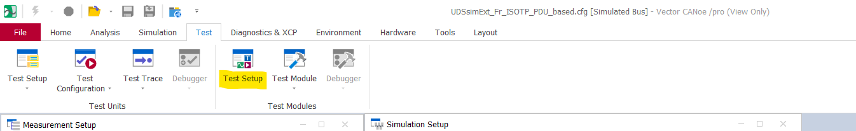

- Right-click on Test Setup and Create New Test Environment
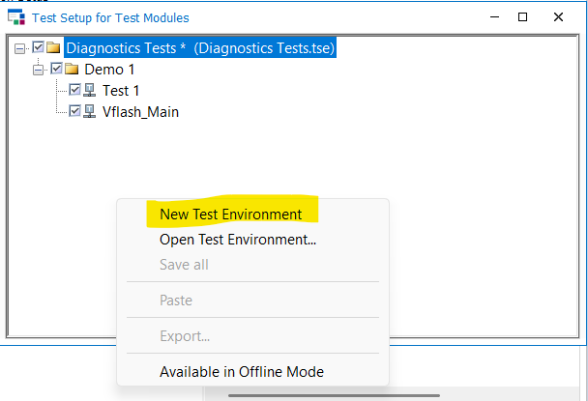

- Add the CAPL Test module under the new Test Environment.
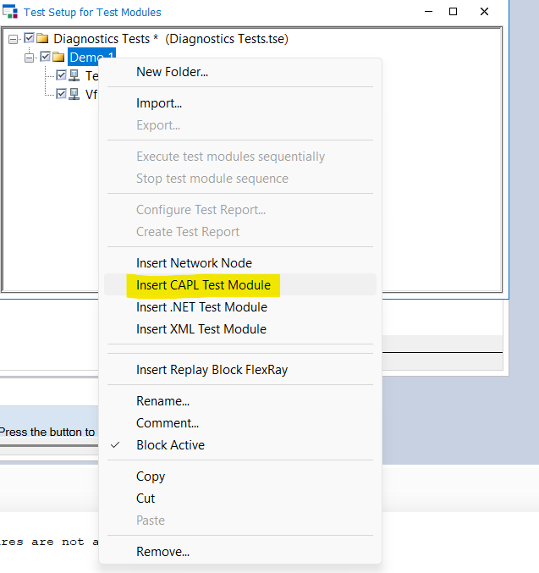

- Right-click on the added “CAPL Test Module”. Click on “Configuration”
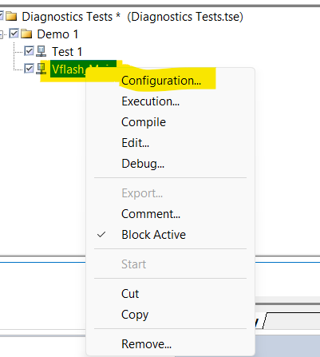

- Update Name and add Can file in the Test Script
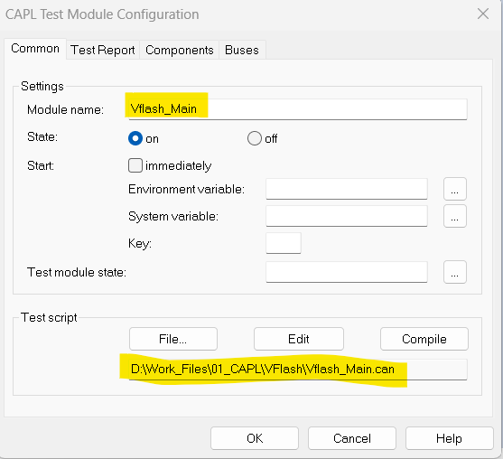

- Go to the components -> Add vFlashNodeLayer.dll/ vFlashNodeLayer.vmodule. This file could be found under the installation folder of Canoe inside Exec64 folder as shown below:
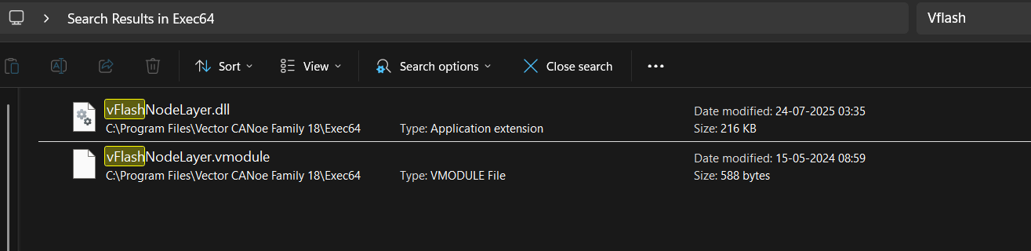
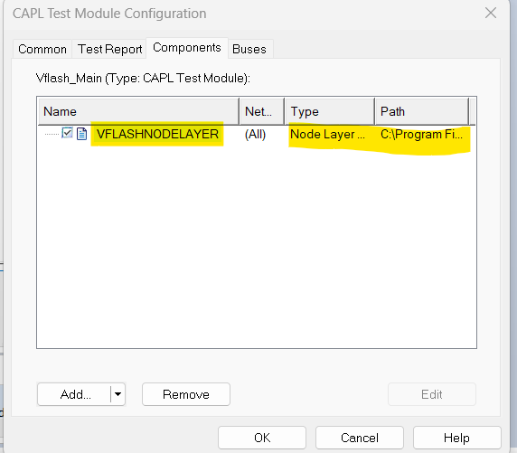
- Click on “OK” to save the configuration.
- Right-click on the CAPL test module. Click on the “Edit” button. The CAPL browser will be open.
- Vflash_main.can will open as shown below:
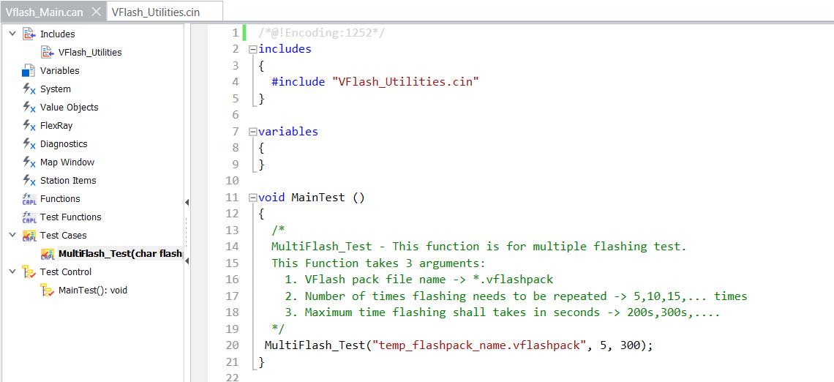

- Update Vflash_main.can file based on the test scenarios. Click on the Compile button for compilation issues. If no errors, you can start the Canoe simulation.
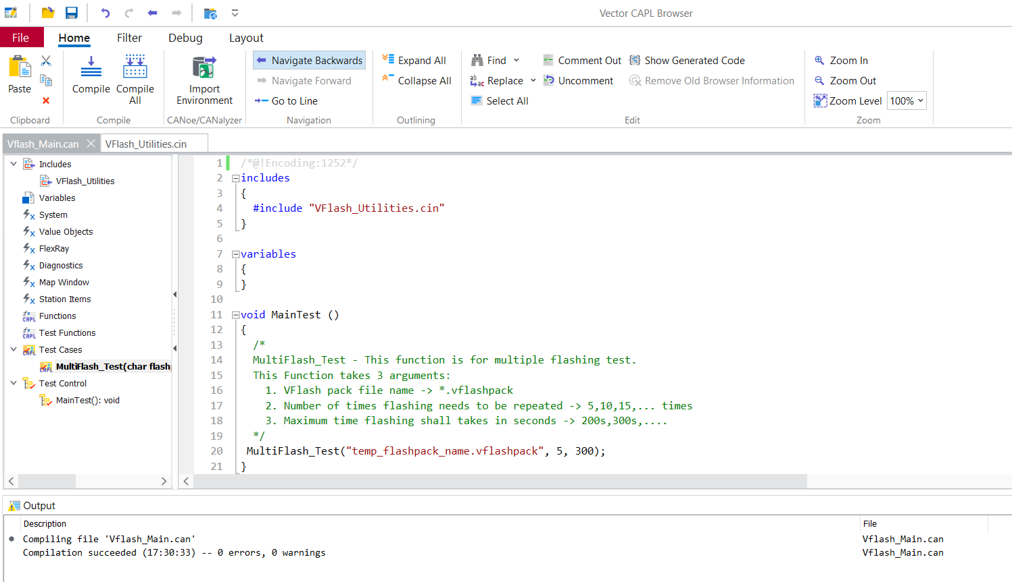
- Go to the CAPL Test module “Vflash_Main”. Right-click on it and select “Execution”.
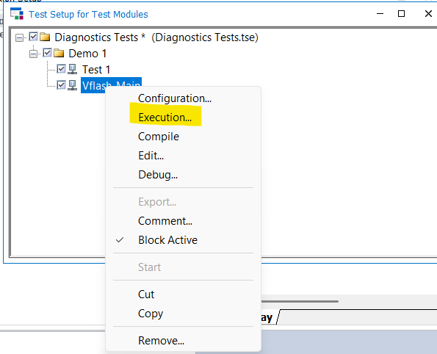
- New window will open. Click on the yellow highlighted button to execute and red button to see the executed report.
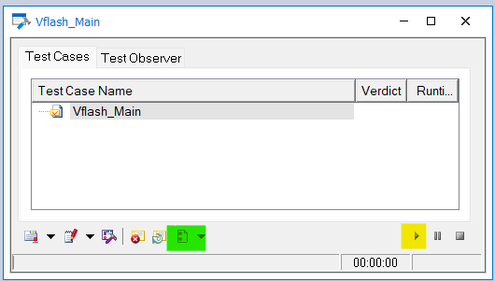
Test scenarios available in CAN file as of now:
- Single-time flash test with flashing time verification
- Multiple flash Test with flashing time verification
- Signature, Checksum corruption test
- Diagnostic services applicable in Appl/bootloader -> Function template is available. You can use it for all the services.

